After socially distanced
Cricket activity in Wales

Training Over !    Exit the field observing social distancing. | Sanitise your bat and hands.
   |  | 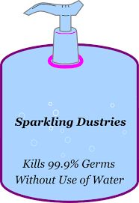
Shared equipment    A club representative will collect and disinfect shared equipment |   If you wish to attend a social gathering at the club after the match, please be aware of Welsh Govt. guidelines. Opening outside 26th April.
Stay Safe and Stay Alert

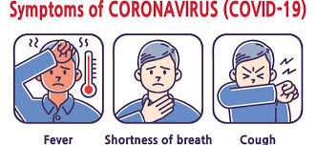

If you or anyone in your household show any signs of Covid – 19 following the use of our facility, report it to the “Test, Trace and Protect” system to limit the spread of the virus.

