Before socially distanced
Cricket activity in Wales

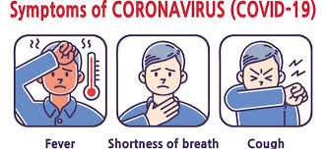  Undergo a personal symptom check at home prior to matches. Stay at home and do not take part if you demonstrate any COVID -19 symptoms. |   If you have been asked to isolate by “Test, Trace and Protect”, please do not come to the venue,  stay at home.
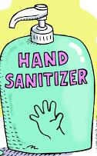  Wash your hands at home before and after cricket activity. Take your own sanitiser to training and matches. |   Travel safely either by car on your own or with your household, or on public transport following Welsh Govt. advice.
  Take your own refreshments. Do not share drinks bottles. |   Toilets are closed also the clubhouse and changing rooms. Toilets will be opened from 26th April.
  Arrive in your kit, on time, and ready to train or play. |   Register with the person taking the training or your captain, giving your contact details.

