During socially distanced
Cricket activity in Wales
Familiarise yourself with the layout, and where you can go.  Parents and carers (except those helping a disabled cricketer) must stay off the cricket field. When spectators are allowed this will change but please remember social distancing at all times. |   Use own equipment throughout where possible and clean your bat when leaving field of play.
   | Read the plan
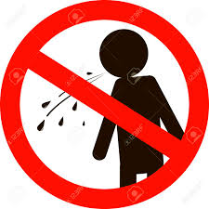  No saliva or sweat to come into contact with the ball at any time.  No spitting. | Fielder ➔ ➔ ➔ Bowler  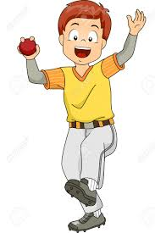  The ball must be immediately returned to the bowler, and not passed between players.
Remember the coaches and captains are here for you; please ask if you are unsure about anything.  We all want you to enjoy your cricket | Puzzled

